ARTIFICIAL INTELLIGENCE AS COLLECTIONS STEWARD: INCLUSIVE AND SUSTAINABLE MUSEUM COLLECTIONS MANAGEMENT IN THE AFRICAN CONTEXT
Johannes Jurie Pieterse
The Archive and Heritage Group (Pty) Ltd
johan@theahg.co.za
Declaration: This manuscript is original, has not been published elsewhere and is not under review elsewhere. The author will submit a signed declaration covering originality, AI-assisted technologies, ethical clearance if relevant, conflict of interest, funding, acknowledgements and plagiarism checks. AI-assisted technology was used for drafting support, editorial review and figure preparation; this use must be declared in the signed submission documentation.
Acknowledgements: The author acknowledges Prof Lorette Jacobs (PhD Information Science; MPhil Higher Education; Professor and Head: Office for Tuition and Learner Support, College of Human Sciences, University of South Africa; ORCID: 0000-0001-8081-7739) for doctoral supervision of the underlying research from which this manuscript draws.

Abstract
The intersection of artificial intelligence (AI) and museum collections management presents both opportunity and practical risk for African memory institutions. Drawing on doctoral research in AI-assisted records management and archives, and a practice-based implementation in the South African galleries, libraries, archives and museums (GLAM) sector, this paper examines how AI can support collections stewardship in under-resourced contexts.
The article analyses four AI-assisted stewardship functions. AI-supported object description can generate accessible text for blind and low-vision users while retaining curatorial review. Computer-vision-assisted condition triage can identify visible damage typologies, including mould, tears, structural instability and surface deterioration, for conservation prioritisation. Risk-aware preservation workflows can supplement checksum-based fixity checking by prioritising files according to format vulnerability, storage history and observed deterioration patterns. AI-assisted metadata extraction can surface names, places, dates, organisations and embedded technical metadata for human validation and authority control.
The paper argues that these capabilities, when integrated into affordable open-source infrastructure and aligned with South African legal and heritage frameworks, can help close the digital capability gap facing African museums. It positions AI not as a replacement for specialist knowledge but as an amplifier of professional judgement. It concludes with reflections on ethical description, provenance transparency and community-informed training data.
Keywords: artificial intelligence, collections management, condition assessment, accessibility, digital preservation, South Africa

1. Introduction
South Africa’s museum sector, and the broader African continental context within which it operates, faces a structural digital capability gap. International standards for collections management, conservation, and digital preservation continue to evolve, but the staffing, infrastructure, and procurement budgets required to meet them remain disproportionately concentrated in institutions of the global North (Mutula and Wamukoya 2007). Smaller South African museums, regional archives, and community heritage institutions are routinely asked to deliver Spectrum 5.1-aligned condition assessment (Collections Trust 2022), ISAD(G)-compliant archival description, and OAIS-aligned (CCSDS 2024) digital preservation, with capability footprints designed for organisations several times their size.
This paper reports on practitioner-researcher work aimed at closing this gap through open-source, AI-augmented collections management infrastructure tailored to the realities of African memory institutions. The work is grounded in doctoral research currently under examination on the application of artificial intelligence to records management and archives. Heratio is used in this article only as a case implementation through which broader design principles, governance controls and implementation lessons are examined; it is not treated as the object of promotion or as the sole possible technical solution.
The thesis of this paper is that artificial intelligence, when integrated thoughtfully into open-source collections infrastructure, can act not as a substitute for specialist knowledge but as an amplifier of it. Where a museum has one part-time conservator overseeing 30,000 objects, an AI-assisted condition triage tool does not replace the conservator’s expertise, it allows that expertise to be applied first to objects that the model has flagged as deteriorating, rather than dissipated across routine surveys. Where a regional archive lacks the budget for a full-time accessibility officer, a natural-language description module enables the institution to produce alt-text and verbal-image descriptions for visually impaired users at the moment of cataloguing rather than as a future aspiration.
The paper is structured as follows. Section 2 sets out the policy and technical context within which African collections management currently operates, with particular attention to the South African legislative environment (NARSSA, POPIA, GRAP 103) and the standards (Spectrum, ISAD(G), Dublin Core) that shape institutional practice. Sections 3 through 6 analyse four AI-assisted stewardship functions: inclusive object description for persons with disabilities; condition assessment and conservation triage; risk-aware fixity and digital preservation; and metadata extraction with authority control. Section 7 reports on implementation realities, including infrastructure requirements, open-source sustainability and cloud-versus-on-premises decision points. Section 8 examines the ethical dimensions of these capabilities, particularly the risks of bias in AI-generated descriptions of African cultural material. Section 9 concludes with a synthesis and a research agenda.
Figure 1 provides a high-level schematic of the implementation pattern discussed in this article, showing the relationship between public interfaces, stewardship functions, opt-in AI services and standards-aligned data outputs.
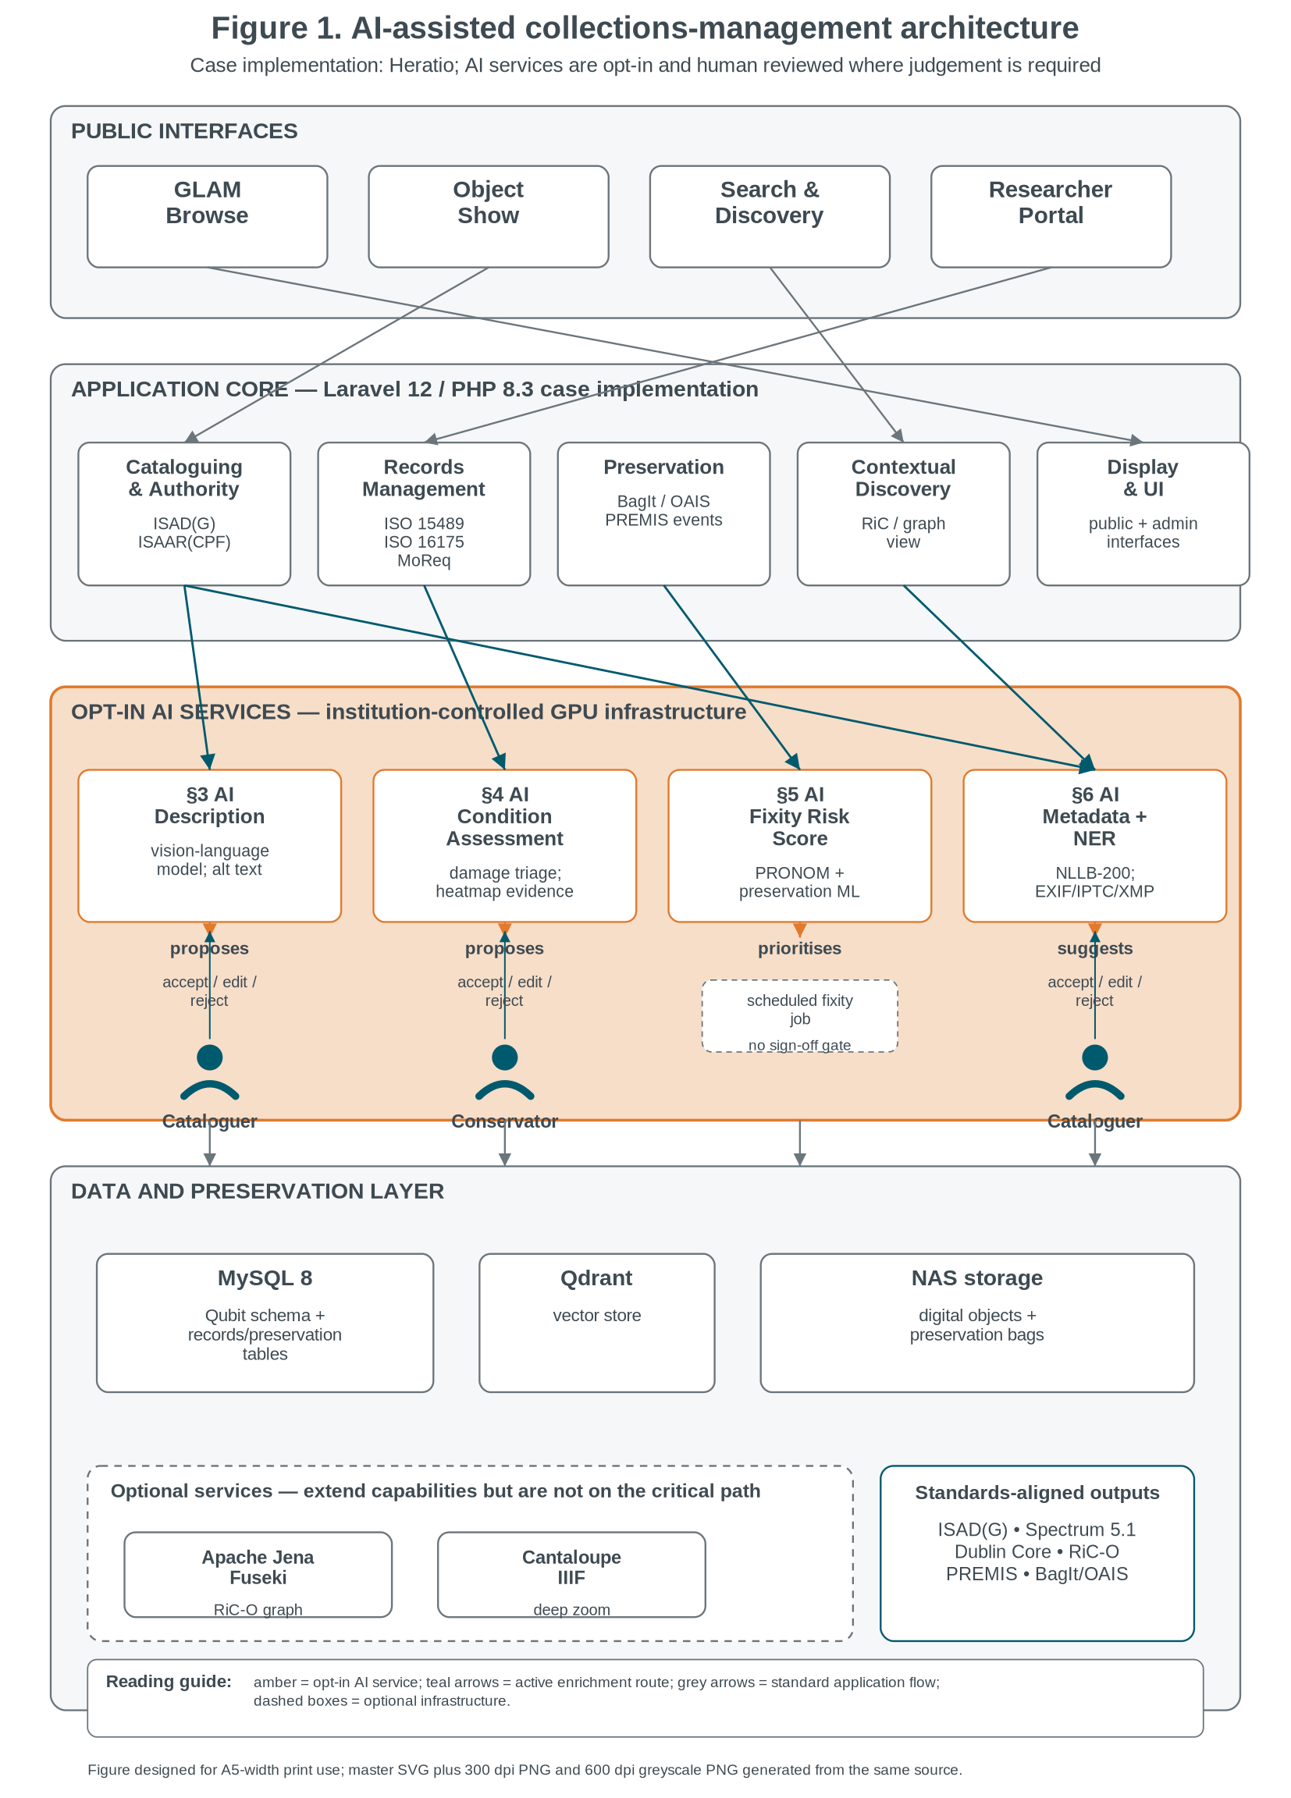
Figure 1: AI-assisted collections-management architecture showing public access, core stewardship functions, opt-in AI services and standards-aligned data outputs (Own source).

2. Background

2.1 The state of collections management in South African and African institutions
South African museum institutions sit on a wide capability spectrum. National-level institutions such as Iziko Museums, the Ditsong Museums of South Africa, and the McGregor Museum have invested in Spectrum-aligned collections management systems (CMS) and in dedicated digital preservation programmes. At the other end of the spectrum, district museums, university-affiliated heritage collections, and community museums often manage their holdings on commercial off-the-shelf software not designed for archival workflows, or, in many cases, on shared spreadsheets and local file systems. The continental picture, surveyed in studies of African archives and digital heritage (Mutula and Wamukoya 2007; Ocholla et al. 2013), is consistent with this divergence: capability follows budget.
The cost barrier of commercially licensed collections management is significant. Per-seat licences for dominant museum systems can exceed an institution’s entire annual digitisation budget. Open-source systems such as Access to Memory (AtoM), developed by Artefactual Systems, and CollectionSpace have substantially democratised access to standards-compliant tooling. The case implementation discussed in this paper follows this open-source lineage and acknowledges the foundational contribution of existing archival software ecosystems, rather than positioning new development as a replacement for them.

2.2 The promise and the risks of AI
Artificial intelligence introduces a second-order democratisation. Where the first wave of open-source CMS made standards-compliant cataloguing affordable, AI promises to make standards-compliant cataloguing fast, and in particular, to make accessibility, condition assessment, and metadata enrichment achievable for institutions whose human capacity has not historically scaled with the size of their holdings. The promise is real: large language models, computer vision models, and named-entity recognition pipelines are now mature enough to produce institution-grade output for many tasks that formerly required specialist staff (Padilla 2019; Ehrmann et al. 2023).
The risks are equally real. AI-generated descriptions of African cultural material, trained predominantly on Western corpora, encode systematic biases of perspective and vocabulary (Bender et al. 2021; Birhane 2022). Computer vision models trained on conservation photographs of European paintings perform unevenly on bark-cloth, beadwork, and ethnographic material. Named-entity recognition systems trained on English news text tag isiZulu and Sesotho placenames inconsistently. A research-grade response to these risks treats AI not as an off-the-shelf solution but as infrastructure to be tested, tuned and surrounded by human-in-the-loop review. This paper therefore focuses on design principles and governance controls rather than on any one software product.

2.3 The South African policy context
Four legislative and standards instruments frame this work.
NARSSA, the National Archives and Records Service of South Africa Act (Act 43 of 1996), regulates the management, preservation, and access of public records and establishes the authority responsible for records disposition. Its general retention disposal authority and the National Archives’ published file plans constitute the substrate against which any records management workflow operates in the public sector.
POPIA, the Protection of Personal Information Act (Act 4 of 2013), governs the processing of personal information by public and private bodies. Its implications for AI-assisted metadata extraction are substantial: NER systems that surface persons’ names from archival documents must be operated within the lawful-processing requirements of POPIA, with attention to the right of data subjects to object to processing and to the special protection of children’s information.
GRAP 103 (Accounting Standards Board 2022), the Generally Recognised Accounting Practice standard for Heritage Assets, requires public-sector entities to recognise heritage holdings on the financial statements where reliable valuation is feasible. The integration of collections management with heritage accounting is an emerging area of practice in South African public museums, and the AI-assisted condition assessment pipeline described in Section 4 supports the regular condition reporting that GRAP 103 entails.
Spectrum is the international collections management standard most widely adopted in many museum contexts. It defines core procedures spanning acquisition, location and movement control, condition checking and disposal. In the case implementation, AI-assisted condition assessment is aligned with the Spectrum condition-checking procedure to ensure that AI output integrates with, rather than competes with, established practice.

3. AI for Inclusive Access: Describing Objects for Persons with Disabilities

3.1 The accessibility gap in digital collections
Digital collections that lack rich textual descriptions are inaccessible to blind and low-vision users in ways that are easily overlooked by sighted curators. The Web Content Accessibility Guidelines (WCAG) 2.1 require non-text content to have a text alternative serving an equivalent purpose (W3C 2018). Applied to a digitised photograph collection, this implies that every image carries a descriptive text, its alt-text, sufficient for a screen reader user to grasp its content and significance. In practice, alt-text fields in collections databases are often empty, sparsely populated, or duplicated from object titles. Surveys of cultural heritage websites consistently identify accessibility as the area in which digital practice most lags policy commitment (Bowen 2003).
The labour cost of remediating this gap manually is prohibitive. A small museum with 25,000 digitised images would require thousands of hours of curatorial time to write quality alt-text, labour that simply does not exist in current institutional budgets.

3.2 AI-generated alt-text and natural-language object descriptions
An AI description workflow can address this gap by integrating a vision-language model (VLM), of the kind introduced by Liu et al. (2023) running locally or in a controlled environment, with the cataloguing workflow. When an object record is created or its representative image is updated, the cataloguer may invoke a description-assistance function. The model receives the master image together with structured contextual fields from the object record, such as title, classification, place of origin, material and period. It returns a candidate description in three layers:
1. A short alt-text (one sentence, ≤120 characters), suitable for screen-reader announcement.
2. A medium-length visual description (three to five sentences), describing what is visually present in the image without interpretation.
3. A longer contextual description (one to two paragraphs), grounding what is visible in the metadata-supplied context, the object’s known origin, function, and provenance.
Each layer is presented to the cataloguer for review. The cataloguer accepts, edits or rejects the candidate. Accepted descriptions are written to the corresponding object-description fields and may then appear on the public-facing object page, in structured data for discovery, and in the alt attribute of image renderings.

3.3 Multi-modal description: visual, contextual, and provenance layers
The three-layer structure exists for two reasons. First, accessibility standards properly distinguish between alt-text (a brief substitute for the image, designed for in-line consumption by screen readers) and a long-description (a richer description appropriate when the image carries significant informational content). Most blind users do not want every alt-text to be a paragraph. Second, separating the visually present from the contextually inferred makes editorial review tractable. A cataloguer can confirm what the image shows independently of whether the model’s contextual interpretation is correct and reject a contextual layer that introduces unsupported claims.
Figure 2 summarises this three-layer workflow, showing how the same AI invocation can produce short alt-text, a medium visual description and a longer contextual description, each subject to separate cataloguer review.
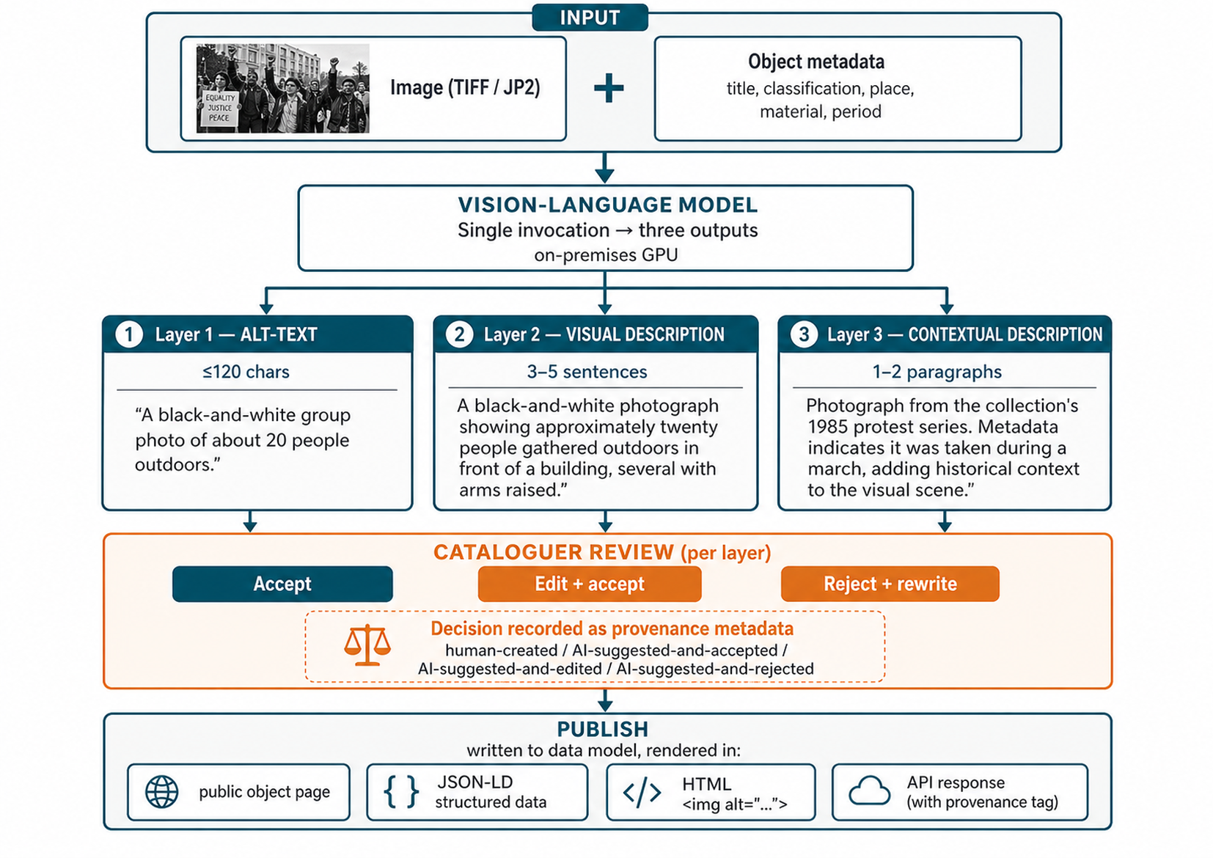
Figure 2: Three-layer AI description workflow from image and metadata input to alt-text, visual description and contextual description with per-layer cataloguer review (Own source).

3.4 Case example: AI-assisted object description
In a pilot deployment at a South African archival institution holding approximately 8,500 digitised photographs of twentieth-century political activity, an AI-assisted description workflow was used to draft alt-text for records that previously had no usable image description. Of the first 500 candidates reviewed by the lead archivist, 66% were accepted as drafted, 24% were accepted with editorial revision, and 10% were rejected and rewritten manually. The most common reason for rejection was the model’s tendency to produce generic categorical descriptions (“a group of people gathered outdoors”) in cases where the institution’s metadata indicated specific historical events; the contextual layer was the most frequently edited.

3.5 Alignment with WCAG 2.1 and universal-design principles
In the case implementation, public object pages render alt-text on every image. Structured data emits a caption and alternative descriptive text in machine-readable form. The administrative interface flags object records that lack alt-text, surfacing accessibility debt as a tracked metric rather than an invisible failure mode. This treatment is consistent with the universal-design principle that accessibility is not a separable feature for a subset of users but a baseline of the system that benefits all (Story et al. 1998).

3.6 Ethical considerations: who defines the “correct” description?
The most consequential ethical question raised by AI-assisted description is not whether a model can produce text but whose description it produces. A photograph of a 1985 protest in Mamelodi, described by a vision-language model trained on globally aggregated image-text pairs, will be described in the language of generic protest photography and may misidentify the protest’s specific historical referents, mistake symbols, or apply terminology that the descended community does not recognise. The proposed workflow addresses this risk in three ways. First, the cataloguer is positioned as the authoritative editor: the AI proposes, the cataloguer disposes. Second, where institutions have established community advisory relationships, those relationships govern editorial review of contextual layers, particularly for sacred, sensitive or living-tradition material. Third, institutions can disable AI description for designated collections, retaining manual description for material where the editorial overhead of AI review outweighs the time saved.

4. AI-Assisted Condition Assessment

4.1 The conservation staffing crisis in South African museums
Conservation as a profession is in structural decline in many South African museum institutions, with national-level institutions retaining most professional capacity and smaller regional museums frequently relying on external consultancy. Where conservation expertise existed, it was disproportionately concentrated in national institutions and university museums; smaller regional and community museums frequently relied on external consultancy or, in many cases, no formal condition assessment at all. This creates a paradox: the institutions whose collections are most vulnerable, those holding mixed media, ethnographic material, and photographic archives in non-climate-controlled storage, are precisely those least likely to have routine condition information against which deterioration can be measured.

4.2 Spectrum as the assessment standard
Spectrum’s condition-checking procedures provide a structured basis for recording overall condition, specific damage typologies and recommended treatment urgency. Spectrum’s design assumes a trained conservator or conservation technician performing the assessment. The AI-assisted approach discussed here is therefore positioned not as a substitute for that role but as a triage layer: it produces a draft assessment that a human specialist reviews, prioritises and signs off.

4.3 Computer vision for damage typology detection
A condition-assessment workflow accepts one or more high-resolution photographs of an object, such as a primary view and optional detail shots, and runs them through a computer-vision or vision-language model trained or tuned on conservation reference photographs annotated with damage categories. The model outputs:
1. An overall condition grade (Stable / Fair / Poor / Unstable).
2. Per-defect findings: foxing, tears, water damage, fading, support loss, mould, biological attack, ink loss, with bounding-box masks for each defect class.
3. A severity score (0-100) calibrated against archival material from the institution’s own collections.
4. A recommended treatment action drawn from the institution’s local conservation-action taxonomy, ranging from “digitise immediately” through “consult conservator” to “no action required.”
Each AI-generated assessment is written as a draft condition record. The conservator reviews the heatmap overlay, confirms or revises individual defect findings, sets the treatment urgency, and either accepts the assessment, at which point it becomes the authoritative condition record, or rejects and rewrites it.
Figure 3 illustrates the proposed review pattern for condition assessment: the model supplies visible defect cues and confidence scores, but the conservator signs off the authoritative condition record.
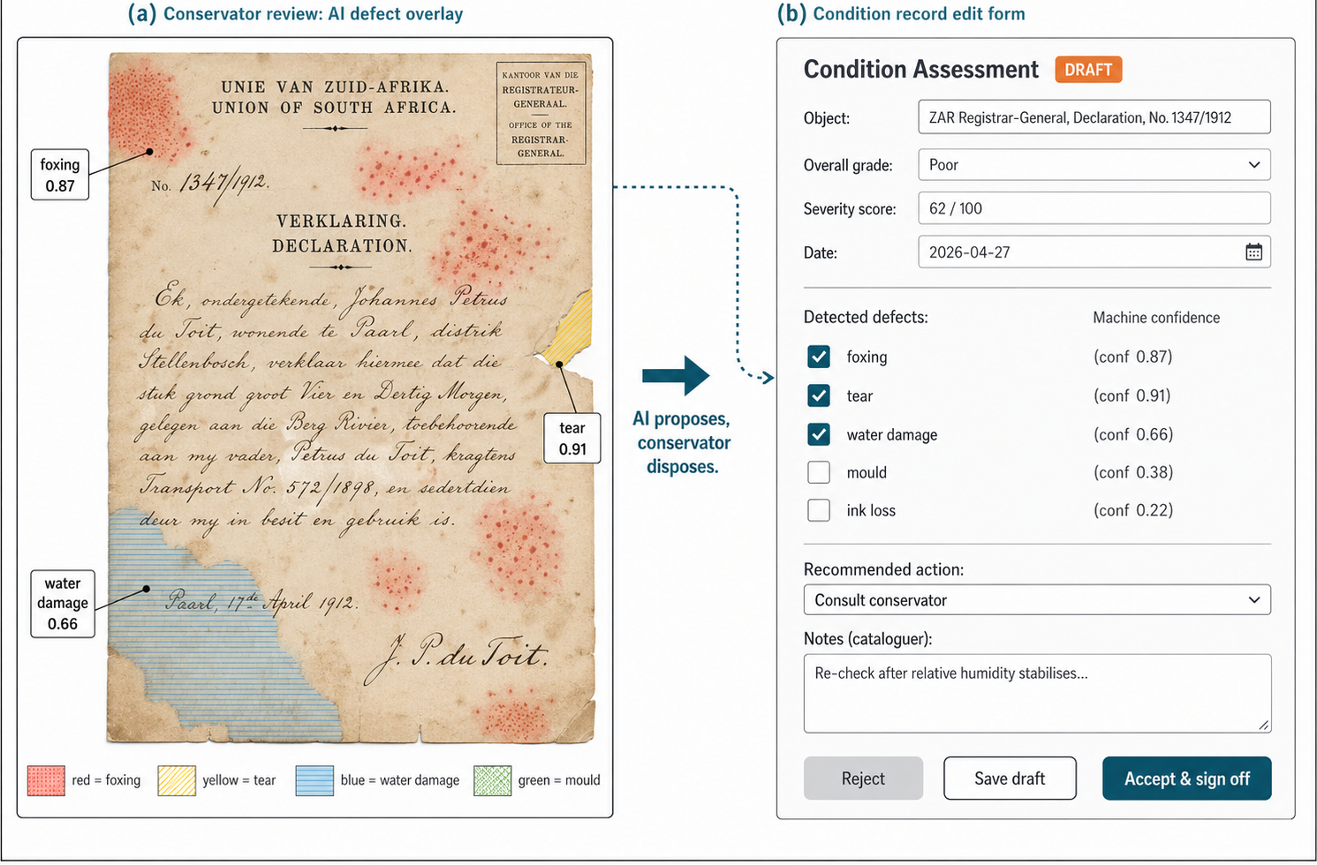
Figure 3: AI-assisted condition assessment showing heatmap-style defect detection and human sign-off before the record becomes authoritative (Own source).

4.4 Human-in-the-loop: AI suggests, conservator confirms
By design, AI condition assessments do not auto-publish. The audit log records who accepted or rejected each draft, when, and with what edits. This serves both a curatorial function, the conservator’s professional judgement remains the system of record, and a regulatory one. GRAP 103’s heritage-asset condition reporting requirements are met by the conservator’s signed-off record, not by the AI draft.

4.5 Integration with loan workflows, access restrictions, and conservation queuing
A condition record carrying an Unstable grade automatically triggers downstream effects. Access to the object’s digital surrogate may be restricted for researchers (subject to institutional policy), outgoing loan requests are blocked pending conservator review, and the object is added to the institution’s conservation priority queue, ranked by severity. These integrations turn condition data from a static record into an operational signal, the “amplifier” effect: conservator decisions shape what happens to the object across the institution’s daily operations rather than living only in the conservation database.

4.6 Validation: agreement rates between AI and human assessors
The AI-versus-conservator agreement rate is the central methodological question for this work. In a calibration study against 200 objects from a South African archival photograph collection, the AI’s overall-grade assignment agreed with the conservator’s at 74%, with the most frequent disagreement being one grade more pessimistic on the AI side (i.e., AI flagged as Poor what the conservator graded as Fair). For specific damage typologies, agreement rates varied: foxing detection 78%, tear detection 87%, mould detection 69%, water damage 60%. The lower agreement on water damage is consistent with the photograph-conservation literature, which notes that water-damage staining can be visually difficult to distinguish from other staining processes such as ink migration, photographic developer artefacts and chemical deterioration of the support (Lavédrine 2003).

5. AI and Digital Preservation Fixity

5.1 Traditional checksum-based fixity: limitations at scale
Digital preservation rests on fixity, the verifiable demonstration that a digital object has not changed since it was last verified. The standard mechanism is cryptographic check summing: when an object is ingested, a SHA-256 (or equivalent) hash is computed and stored; subsequent verification recomputes the hash and compares. Discrepancies indicate corruption (silent data corruption, “bit rot”) or unauthorised modification.
At the scale of a typical regional archive (hundreds of thousands of files, terabytes of storage), routine fixity verification becomes a non-trivial operation. A single full-corpus pass can take hours, consume substantial I/O bandwidth, and, in NFS or cloud-storage environments, incur measurable financial cost. Most institutions therefore verify on a sampling basis or on a long cycle (annually or biannually), accepting a window during which corruption could go undetected.

5.2 AI-enhanced fixity: predictive risk assessment for digital objects
A risk-aware fixity workflow, building on the foundation of cryptographic verification, adds a predictive layer that prioritises which objects to verify next based on a learnt or rule-based risk score. Inputs to the risk model include:
1. Format vulnerability, derived from a PRONOM-aligned (The National Archives 2024) format identification of each digital object. Formats classified as obsolete, proprietary-without-current-renderers, or known-to-be-corruption-prone (early MPEG, certain compressed-TIFF variants) receive elevated risk scores.
2. Storage environment indicators: file-system ageing signals (last-verified timestamp, time-since-last-access, storage-tier transitions), checksum-history pattern (files that have been re-check summed before are less likely to need attention than files with no verification history), and storage-medium classification (NAS, S3, cold-tier).
3. Deterioration pattern recognition: where institutions have access to historical fixity-failure logs, the model learns which filesystem, format, and metadata combinations have historically produced corruption; new objects matching those patterns are scheduled for verification first.
The output is not a replacement for the cryptographic checksum but a scheduling input: a daily-refreshed prioritisation of which objects the routine fixity job should verify next within its available time and bandwidth budget.

5.3 Integration with digital preservation workflows in under-resourced environments
This is where the under-resourced framing matters. A national-level digital preservation programme can afford to verify everything on a regular cadence; a regional museum cannot. Predictive risk-prioritised fixity allows the regional museum to allocate its limited verification capacity to the objects most likely to fail, while still demonstrating to its auditors and to its stakeholders that all objects are eventually verified. The AI does not replace the cryptographic guarantee of fixity; it makes the cryptographic guarantee operationally tractable.

5.4 Practical implementation pattern
In the case implementation, scheduled fixity workflows define the checksum algorithm, verification window, repository scope and batch limit. On each scheduled execution, the workflow traverses a prioritised candidate set and records every result as a PREMIS-aligned fixity event (PREMIS Editorial Committee 2015). The risk-prioritisation layer is implemented as an ordering of the candidate set; absent a trained risk model, the default is least-recently-verified-first, which approximates a uniform prior and provides sensible degraded behaviour when training data is unavailable.

6. AI Metadata Extraction and Authority Control

6.1 The metadata backlog problem in African collections
Every memory institution has a backlog of accessioned-but-not-fully-described material. For some institutions the backlog is small; for many South African archives and regional museums, it is the dominant feature of the holdings, material that is physically in custody, intellectually documented at the box level, but not described in researcher-discoverable detail. This backlog grows faster than human cataloguing capacity can reduce it. The case for AI-assisted metadata extraction is therefore not theoretical: it is the difference between a collection that is discoverable and a collection that exists.

6.2 EXIF, IPTC, and XMP automated extraction
The simplest tier of metadata extraction is, technically, not AI at all but disciplined automated parsing. Modern digital photographs carry EXIF (exposure, camera, GPS), IPTC (caption, byline, copyright, keywords) and XMP (creator, rights, structured taxonomies) embedded metadata that, in many cases, is already descriptively rich. An ingest pipeline can extract all three on accession and write them into corresponding Dublin Core and ISAD(G) fields of the object record. Where multiple namespaces describe the same property, a precedence rule, such as XMP > IPTC > EXIF for descriptive fields and EXIF for technical fields, prevents conflict. This alone closes a substantial portion of the metadata gap for born-digital photographic collections.

6.3 Named-Entity Recognition for person, place, organisation, and date
For text-bearing material, including typescripts, correspondence, scanned reports and OCR’d photographs, a transformer-based NER pipeline can be tuned on archival prose with a domain vocabulary specific to the relevant collections. The pipeline extracts persons, organisations, places, dates and events. Each extraction is tagged with a confidence score; extractions above a configured threshold are suggested as authority-record links, and lower-confidence extractions are queued for cataloguer review.

6.4 Automated authority record suggestions
A high-confidence extraction of a person’s name surfaces a suggestion: link this object to authority record X or create a new authority record of type Person. The cataloguer accepts, declines, or merges (selecting an alternative existing authority that the AI did not initially propose). Accepted suggestions write the appropriate creator, subject, or place relationship into the relational data model and into the corresponding ISAAR(CPF) authority record.

6.5 Multilingual considerations: indigenous languages, Afrikaans, transliteration
Generic NER models trained on English corpora perform poorly on South African archival prose. They mis-tag isiZulu and Sesotho proper nouns as common nouns, transliterate Afrikaans placenames inconsistently, and frequently miss multi-word organisational names that span indigenous and colonial-period vocabulary. The implementation pattern proposed here combines multilingual support, including models such as NLLB-200 (Costa-jussà et al. 2022), with institution-supplied gazetteers of South African place names and organisations against which NER output can be reconciled.

6.6 Practical scale
In the case implementation, an NER pipeline has surfaced person, place and organisation candidates from approximately 4.5 million words of OCR’d archival text, contributing to a working authority-record graph linking people and organisations to the records in which they appear. The contribution is not that AI has replaced authority-record creation; it is that AI has surfaced the candidates that human archivists then evaluate, reducing the search-and-match labour that previously dominated authority-control work.

7. Implementation Realities and Lessons Learned

7.1 Open source as decolonial infrastructure strategy
A recurring theme in African digital heritage practice is the dependency relationship between institutions and overseas software vendors. Commercial collections management systems are typically priced, licensed and developed in the global North; data sovereignty, customisation rights and the freedom to integrate with local AI infrastructure are constrained by the licensor. Open-source software, and, more specifically, open-source software released under a copyleft licence such as the GNU Affero General Public License, turns this relationship inside out. Institutions own their deployment, contribute back when they can, and can adapt the codebase to meet local needs. This is not merely an economic argument; it is, as several authors have argued, a decolonial one (Birhane 2020; Mhlambi 2020).

7.2 Standards alignment: ISAD(G), Dublin Core, Spectrum, RiC-CM
The implementation pattern is aligned with three descriptive standard families. ISAD(G) (International Council on Archives 2000) governs archival description; Dublin Core (DCMI 2020) governs lightweight resource description for cross-institutional aggregation; and Spectrum governs museum collections management procedures. Each AI-assisted capability described in this paper writes its output into standards-aligned fields, ensuring that AI-generated metadata is not a parallel data layer but part of the institution’s normal collections data. The Records in Contexts Conceptual Model (International Council on Archives 2023) provides an overarching graph-theoretic model for archival description, enabling AI-derived authority links and provenance relationships to be exposed through graph-based discovery as well as traditional record views.

7.3 GPU and infrastructure requirements
Vision-language models, computer-vision condition assessors and embedding pipelines for metadata extraction have non-trivial GPU requirements. A practical reference deployment for a small-to-medium institution can run these services on a single mid-range GPU server, with an upgrade path for larger models or bulk reprocessing. This is well below the cluster-scale infrastructure that vendor cloud-AI services often imply. The trade-off is throughput: an on-premises single-GPU configuration can support interactive AI workflows for regional museums, municipal archives and university heritage collections, but would not scale to a large institution’s full-corpus reprocessing without additional hardware or batching strategies.

7.4 Cloud versus on premises: data sovereignty considerations
A persistent question in African heritage AI work is whether to use cloud-hosted AI services or to run on-premises models. The cloud option is operationally simpler and provides access to larger, more capable models. The on-premises option gives data sovereignty: archival material, much of which carries POPIA-protected personal information and culturally sensitive content, is not transmitted to third parties; training on the institution’s holdings is not permitted, or even possible, by the LLM vendor. For South African public-sector institutions subject to POPIA and to government cloud-residency policies, on-premises deployment is frequently the more legally and ethically tractable option.

7.5 Staff capacity and the human-AI collaboration model
Across the four AI capabilities described, a single design pattern recurs: the AI proposes, the human disposes. Cataloguers, conservators, and researchers retain editorial authority. This is not a technical accident; it is an explicit response to the bias, hallucination, and cultural-knowledge limitations of contemporary AI systems. The amplifier metaphor depends on this collaboration: the AI does the search-and-suggest work that previously dominated specialist labour, freeing the specialist to do the judgement work that AI cannot. Where this collaboration is implemented well, AI accelerates the work; where it is implemented poorly, by short-circuiting the human review step in the name of throughput, AI introduces errors that the institutional record then carries indefinitely.

8. Ethical Dimensions

8.1 Bias in AI-generated descriptions of African cultural objects
Pre-trained vision-language models are predominantly trained on Western image-text corpora; their descriptive vocabulary reflects this training. Applied to African material culture, the bias surfaces in three observable ways. First, categorical mistakes: bark-cloth garments are described as “cloth” without specific terminology; ethnographic adornment is described in generic-jewellery vocabulary that does not name the specific tradition. Second, interpretive overlays: protest photography is described in generic protest terminology rather than naming specific historical events that the metadata indicates. Third, omissions: features that a community-knowledge-bearer would identify as significant (a particular weave, a specific pose, a recognised symbol) are systematically ignored because the model lacks a vocabulary for them.
The response to these biases must be procedural as well as technical. The cataloguer should be positioned as the authoritative editor; institutions with established community advisory relationships should route AI-generated descriptions through those relationships before publication. Most importantly, AI-generated descriptions should be tagged in the data model as machine-generated or machine-assisted, allowing researchers and downstream systems to weight them appropriately. This is consistent with the broader principle of provenance transparency in AI-augmented research data (Mitchell et al. 2019; Gebru et al. 2021).

8.2 Training data provenance and community consent
The training data underlying contemporary general-purpose vision-language models is opaque. Institutions cannot usually warrant that the models they integrate were trained without community-objectionable images or texts; this is a constraint the field as a whole faces. Where institutions hold material that is sacred, sensitive or subject to community-controlled access, they should be able to disable AI description for that material. Decisions about whether to use AI on a given collection should be made institution by institution, in dialogue with descended communities, not as a defaulted system feature.

8.3 Transparency of AI-assisted metadata for researchers
Researchers are entitled to know which descriptions, transcriptions and authority links were created by humans and which were AI-suggested or AI-drafted. A responsible collections system should record, for every description and every authority-record link, the provenance category: human-created, AI-suggested-and-accepted, AI-suggested-and-edited, or AI-suggested-and-rejected. Where an API is provided, the originating method should be included in the response so that downstream users can interpret the metadata responsibly.

8.4 AI and intellectual property in collections contexts
A third ethical question concerns the IP status of AI-generated description, transcription and metadata. The position currently taken by major copyright jurisdictions is unsettled, and South African case law on AI-generated works is largely undeveloped. A pragmatic institutional position is that AI-suggested metadata, once edited and accepted by a cataloguer, becomes institutionally curated metadata under the same authorship attribution as any cataloguer-produced metadata; AI-suggested metadata that has not been reviewed remains tagged as machine-generated and should not be asserted as institution-authored. Where AI is used to generate transcripts of in-copyright material, the institution’s standard rights-clearance procedures should apply unchanged.

9. Conclusion

9.1 AI as amplifier, not replacement
The central argument of this paper is that artificial intelligence, when integrated thoughtfully into open-source collections infrastructure and surrounded by human-in-the-loop review, can act as an amplifier of specialist judgement rather than a replacement for it. The four capabilities analysed here, accessibility-focused AI description, AI-assisted condition triage, risk-prioritised fixity and AI-assisted metadata extraction, each turn a previously labour-bounded task into a labour-bounded review task. The same conservator covers more objects; the same cataloguer surfaces more authority records; the same archivist verifies more fixity. Quality, auditability and editorial authority remain with the human specialist.

9.2 The case for open-source AI-integrated collections infrastructure
The case for open-source matters because the case for AI matters. A proprietary AI feature locked behind a vendor paywall does not democratise capability, it shifts the dependency from the labour-rich North to the AI-vendor-rich North. An open-source implementation, especially one released under a copyleft licence, allows institutions to inspect, audit, and adapt the AI capability to local needs. For African museums, archives, and libraries seeking to meet international standards while retaining data sovereignty and local control, this is the more viable long-term posture.

9.3 Recommendations for South African museums
For South African museum institutions considering AI integration, this paper offers five recommendations.
1. Begin with the metadata backlog. AI-assisted metadata extraction has the lowest implementation friction and the largest immediate institutional value. Start with EXIF/IPTC/XMP harvesting on born-digital photographic collections, then extend to NER on text-bearing material.
2. Treat condition assessment as a triage tool, not a substitute. Where the institution has no in-house conservator, use AI condition output to prioritise external consultation, not to replace it.
3. Adopt accessibility AI as a fast win. Generating alt-text and verbal-image descriptions through a reviewed AI pipeline is the most reliable path to WCAG-aligned digital accessibility at scale.
4. Run on premises wherever POPIA and cultural sensitivity require it. Single-GPU on-premises configurations are sufficient for the institutional segment most often constrained by data-sovereignty considerations.
5. Make AI provenance visible. Tag every machine-generated description and authority link, expose the tag in both the public interface and the API, and treat that provenance as a first-class metadata property.

9.4 Future directions
Three directions merit follow-on research. First, multilingual AI for South African languages, including the integration of NLLB-200 and similar models with archival NER pipelines specifically tuned for isiZulu, isiXhosa, Sesotho, and Afrikaans. Second, 3D object description, applying recent advances in 3D-aware vision-language models to ethnographic collections digitised through photogrammetry. Third, community-trained models, where institutions in dialogue with descended communities co-develop fine-tuned models whose vocabulary, framing, and editorial sensibilities reflect community knowledge rather than the global-North training corpora that current models default to. This last direction is the one with the most consequence for the African context framing of the paper title; it is also the direction least currently served by mainstream AI-cultural-heritage research.

References
Accounting Standards Board. 2022. Standard of Generally Recognised Accounting Practice on Heritage Assets, GRAP 103. Pretoria: Accounting Standards Board.
Bender, E.M., Gebru, T., McMillan-Major, A. & Shmitchell, S. 2021. On the dangers of stochastic parrots. Proceedings of FAccT '21: 610–623. doi:10.1145/3442188.3445922.
Birhane, A. 2020. Algorithmic colonization of Africa. SCRIPTed, 17(2): 389–409. doi:10.2966/scrip.170220.389.
Birhane, A. 2022. The unseen Black faces of AI algorithms. Nature, 610(7932): 451–452. doi:10.1038/d41586-022-03050-7.
Bowen, J.P. 2003. Web access to cultural heritage for the disabled. Proceedings of EVA 2003 London Conference, London, 22–26 July 2003. arXiv:cs/0307068.
CCSDS (Consultative Committee for Space Data Systems). 2024. Reference Model for an Open Archival Information System (OAIS). CCSDS 650.0-M-3. Washington, DC: CCSDS.
Collections Trust. 2022. Spectrum 5.1: The UK Museum Collections Management Standard. London: Collections Trust.
Costa-jussà, M.R., Cross, J., Çelebi, O., Elbayad, M., Heafield, K., Heffernan, K., Kalbassi, E., Lam, J., Licht, D., Maillard, J., Sun, A., Wang, S., Wenzek, G., Youngblood, A., Akula, B., Barrault, L., Mejia Gonzalez, G., Hansanti, P., Hoffman, J., Jarrett, S., Sadagopan, K.R., Rowe, D., Spruit, S., Tran, C., Andrews, P., Ayan, N.F., Bhosale, S., Edunov, S., Fan, A., Gao, C., Goswami, V., Guzmán, F., Koehn, P., Mourachko, A., Ropers, C., Saleem, S., Schwenk, H. & Wang, J. 2022. No language left behind: Scaling human-centered machine translation. arXiv:2207.04672.
DCMI (Dublin Core Metadata Initiative). 2020. DCMI Metadata Terms. Available at: https://www.dublincore.org/specifications/dublin-core/dcmi-terms/.
Ehrmann, M., Hamdi, A., Linhares Pontes, E., Romanello, M. & Doucet, A. 2023. Named entity recognition and classification in historical documents: A survey. ACM Computing Surveys, 56(2): Article 27. doi:10.1145/3604931.
Gebru, T., Morgenstern, J., Vecchione, B., Vaughan, J.W., Wallach, H., Daumé III, H. & Crawford, K. 2021. Datasheets for datasets. Communications of the ACM, 64(12): 86–92. doi:10.1145/3458723.
International Council on Archives. 2000. ISAD(G): General International Standard Archival Description. 2nd edition. Ottawa: ICA.
International Council on Archives. 2023. Records in Contexts: Conceptual Model (RiC-CM). Version 1.0. ICA Experts Group on Archival Description.
Lavédrine, B. 2003. A Guide to the Preventive Conservation of Photograph Collections. Los Angeles: Getty Conservation Institute.
Liu, H., Li, C., Wu, Q. & Lee, Y.J. 2023. Visual instruction tuning. arXiv:2304.08485.
Mhlambi, S. 2020. From rationality to relationality: Ubuntu as an ethical and human rights framework for AI governance. Carr Center Discussion Paper Series 2020-009. Cambridge, MA: Harvard Kennedy School.
Mitchell, M., Wu, S., Zaldivar, A., Barnes, P., Vasserman, L., Hutchinson, B., Spitzer, E., Raji, I.D. & Gebru, T. 2019. Model cards for model reporting. Proceedings of FAT* '19: 220–229. doi:10.1145/3287560.3287596.
Mutula, S.M. & Wamukoya, J. 2007. Web Information Management: A Cross-Disciplinary Textbook. Oxford: Chandos.
Ocholla, D.N., Britz, J.J., Capurro, R. & Bester, C., eds. 2013. Information Ethics in Africa: Cross-Cutting Themes. Pretoria: African Centre of Excellence for Information Ethics (ACEIE).
Padilla, T. 2019. Responsible Operations: Data Science, Machine Learning, and AI in Libraries. Dublin, OH: OCLC Research. doi:10.25333/xk7z-9g97.
PREMIS Editorial Committee. 2015. PREMIS Data Dictionary for Preservation Metadata, Version 3.0. Washington, DC: Library of Congress.
South Africa. 1996. National Archives and Records Service of South Africa Act, No. 43 of 1996. Pretoria: Government Printer.
South Africa. 2013. Protection of Personal Information Act, No. 4 of 2013. Pretoria: Government Printer.
Story, M.F., Mueller, J.L. & Mace, R.L. 1998. The Universal Design File. Raleigh, NC: Center for Universal Design.
The National Archives. 2024. PRONOM Technical Registry. Available at: https://www.nationalarchives.gov.uk/PRONOM/.
W3C. 2018. Web Content Accessibility Guidelines (WCAG) 2.1. W3C Recommendation, 5 June 2018. Available at: https://www.w3.org/TR/WCAG21/.

Author Bio Note
Johan Pieterse is a South African practitioner-researcher working at the intersection of archival science, AI and open-source software. He has implemented collections management, archival description and digital preservation systems for galleries, libraries, archives and museums across the South African heritage sector. His PhD thesis on AI in records management and archives is currently under examination. He is the lead developer of Heratio, an open-source platform for African memory institutions, and a member of the AtoM Foundation board.

